UNIVERSITÄT ZU KÖLN

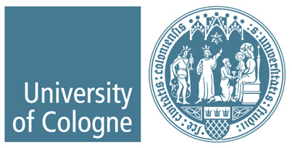

Erasmus+ Program: Academic Year 2021/22
Letter of Confirmation

We hereby confirm that the student ________________________ _

from Universität zu Köln (D KOLN01) has spent his/her period of study at

_____________________________________________ (name of partner institution).

O Virtual mobility
(attended while being in the host country – please exclude online participation while being in Germany):

First day of virtual attendance at host institution for academic purposes: ________________
Last day of virtual attendance at host institution for academic purposes: ________________

O Combined mobility (virtual and physical)
(attended while being in the host country – please exclude online participation while being in Germany)

First day of virtual attendance at host institution for academic purposes: ________________
Last day of virtual attendance at host institution for academic purposes: ________________
First day of physical attendance at host institution for academic purposes: _______________
Last day of physical attendance at host institution for academic purposes: _______________

Note: The student is only entitled to receive an Erasmus+ grant for the mobility period that he/she has physically spent in the host country. Virtual and physical mobility can be combined and/or interrupted. Mobility can include orientation and/or examination period.

Name and function:

Signature:

Date:

Stamp:

Note: This confirmation shall not be issued earlier than five days before the end of the mobility!
----------------------------------------------------------------------------------------------------------------
Wichtig: Bitte senden Sie dieses Dokument innerhalb von 30 Tagen nach Ausstellung per Email an erasmus_students@verw.uni-koeln.de

